Qno 1.3:

Consider a hypothetical 64-bit microprocessor having 64-bit instructions composed of two fields. The first 4 bytes contain the opcode, and the remainder an immediate operand or an operand address.

a. What is the maximum directly addressable memory capacity?

b. What ideal size of microprocessor address buses should be used? How will system speed be affected for data buses of 64 bits, 32 bits and 16 bits?

c. How many bits should the instruction register contain if the instruction register is to contain only the opcode, and how many if the instruction register is to contain the whole instruction?

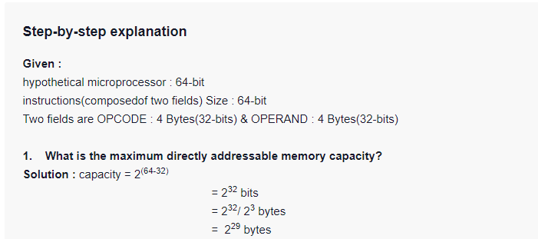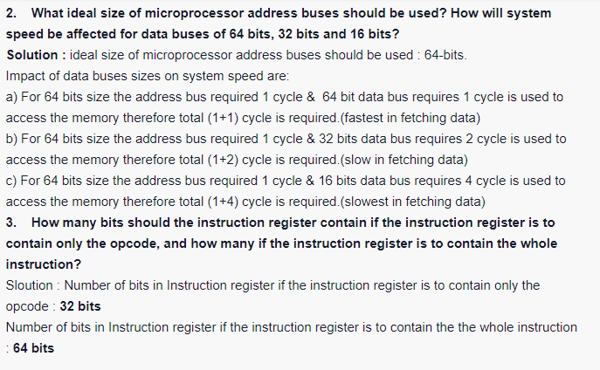

1.4

Consider a hypothetical microprocessor generating a 16-bit address (e.g., assume the program counter and the address registers are 16 bits wide) and having a 16-bit data bus.

a. What is the maximum memory address space that the processor can access directly if it is connected to a “16-bit memory”?

b. What is the maximum memory address space that the processor can access directly if it is connected to an “8-bit memory”?

c. What architectural features will allow this microprocessor to access a separate “I/O space”?

d. If an input and an output instruction can specify an 8-bit I/O port number, how many 8-bit I/O ports can the microprocessor support? How many 16-bit I/O ports? Explain.

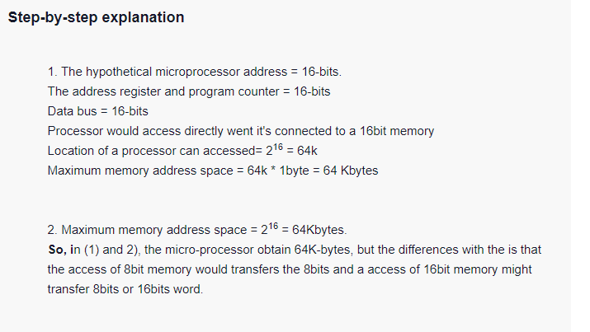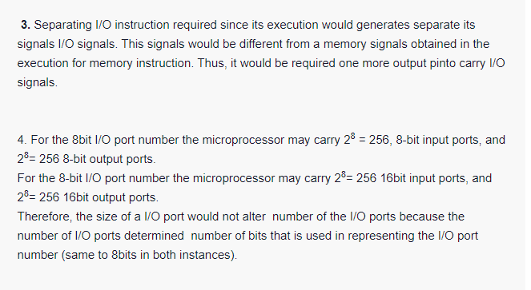

1.6

Consider a computer system that contains an I/O module controlling a simple keyboard/printer Teletype. The following registers are contained in the CPU and connected directly to the system bus: INPR: Input Register, 8 bits

OUTR: Output Register, 8 bits

FGI: Input Flag, 1 bit

FGO: Output Flag, 1 bit

IEN: Interrupt Enable, 1 bit

Keystroke input from the Teletype and output to the printer are controlled by the I/O module. The Teletype is able to encode an alphanumeric symbol to an 8-bit word and decode an 8-bit word into an alphanumeric symbol. The Input flag is set when an 8-bit word enters the input register from the Teletype. The Output flag is set when a word is printed.

a. Describe how the CPU, using the first four registers listed in this problem, can achieve I/O with the Teletype.

b. Describe how the function can be performed more efficiently by also employing IEN.

